ELC REGISTRATION INSTRUCTIONS
- Go to https://drexel.edu/elc/apply/app_forms/online/

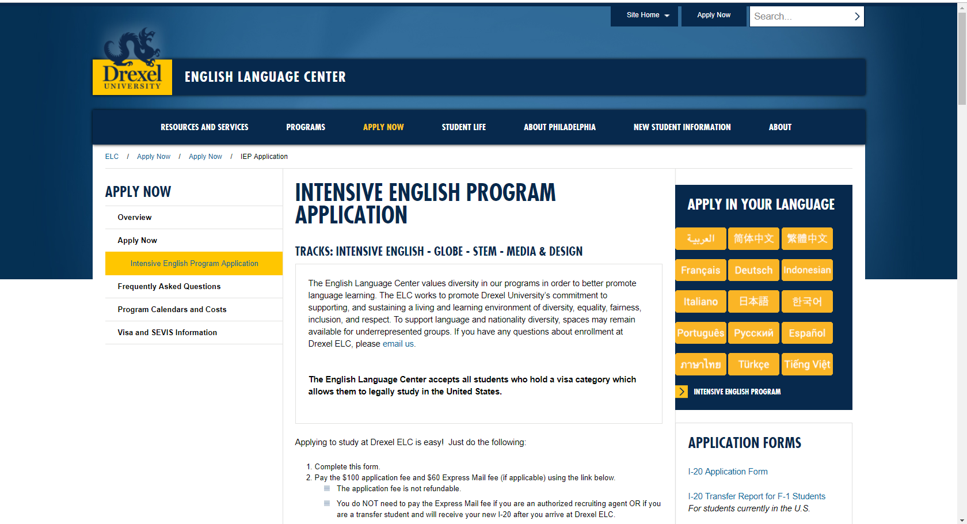

- Scroll down to view application – Enter Student Information
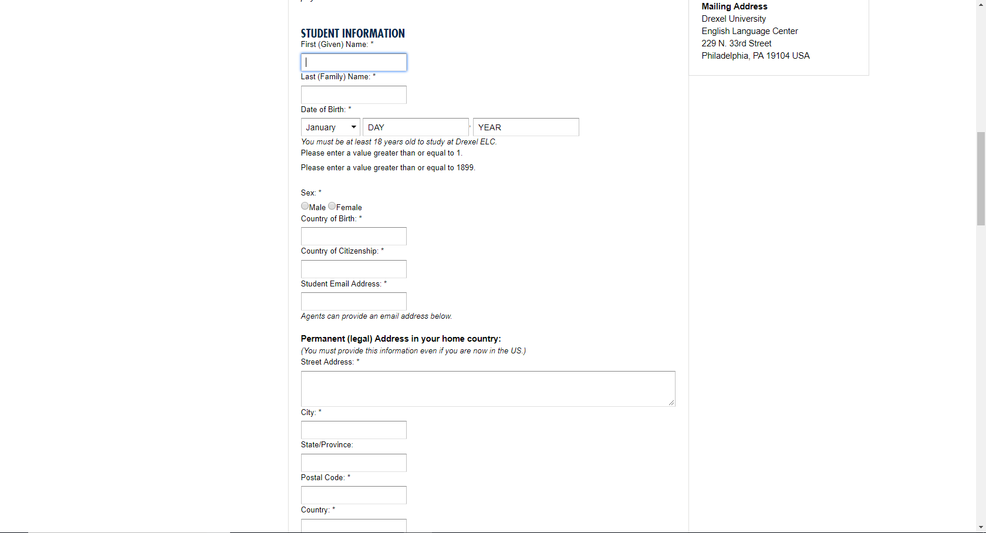

- Enter your address

- Enter I-20 Information & Mailing Address
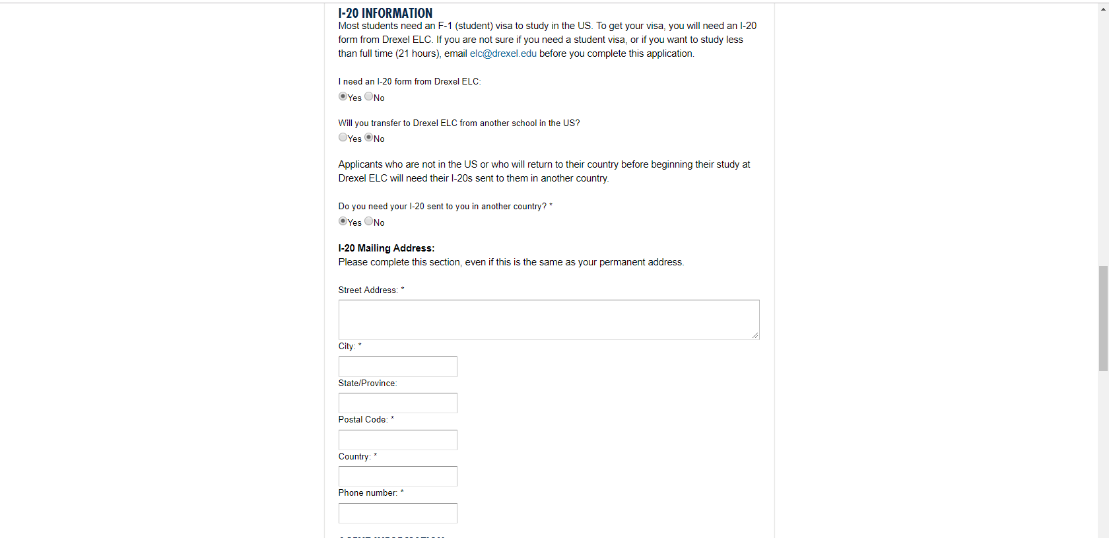

- Make Enrollment selections – Choose SUMMER PROGRAM

- Choose Summer Program Start Date

- Choose Length of Study – Summer Program

- Other Information – Select OTHER & Enter name of YOUR school and program

- Enter Fee Waiver (ELC1815), Accept Terms & Conditions, Sign & Submit Application
