Lanzhou University
International Summer Program Registration System

USER MANUAL

2025

Chapter 1: User Guide

  - Browser Recommendations

To optimize your experience with the International Summer Program Registration System, we recommend using browsers such as Google Chrome, 360 Browser (switched to 360 Extreme Mode), Microsoft Edge, and others for accessing the system.

1.2 Friendly Reminder

1. For situations where there are numerous options in drop-down menus, making it inconvenient to find specific values, the system offers a fuzzy search feature. For example, when filling out application information, in the "Nationality" dropdown menu, typing "chin" will enable you to search and find "China."
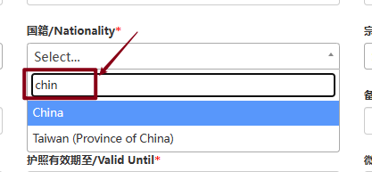
2. Date entries in the system can be obtained either by clicking on the date picker control or by manually inputting the date. For instance, when filling out "Date of Birth," first click on the "Date of Birth" text box to activate the date picker. Then, follow the steps outlined in the following image to select the date.
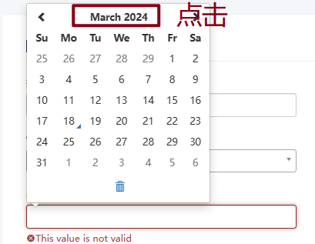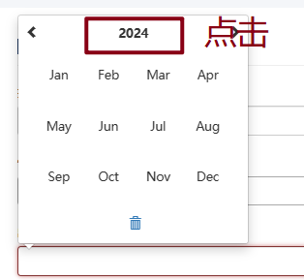

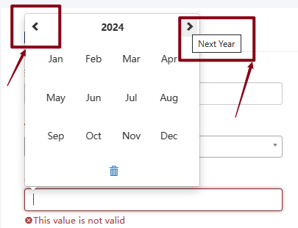

Chapter 2: Login and Registration

2.1 Account Registration

1. Open your browser and enter the following address in the address bar: https://scamp.lzu.edu.cn/apply to access the system's login/registration page. If you don't have an account, please click on "注册 Sign up".
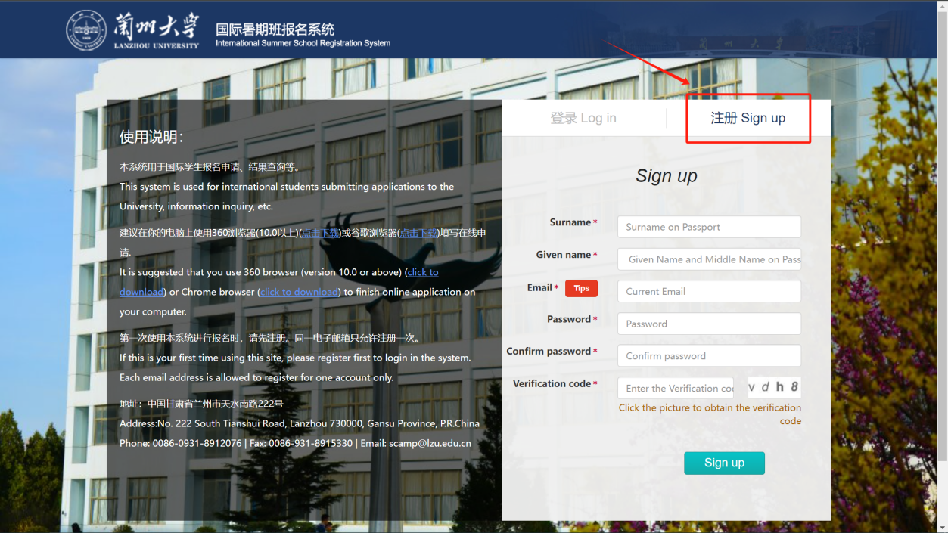

After completing the registration information, click on the "Sign up" button below to complete the registration process.
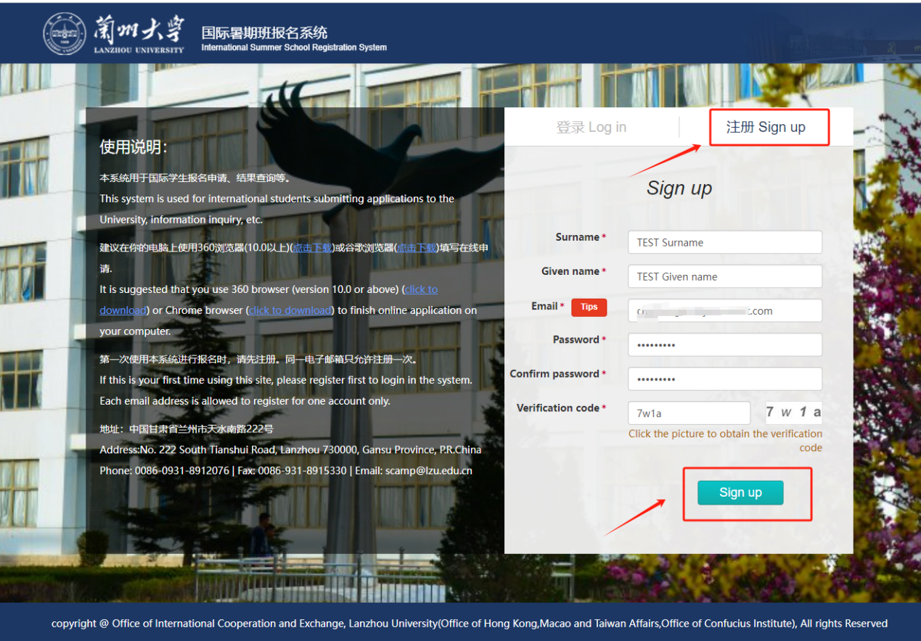

After successful registration, click on the "确认/OK" button below the registration success prompt message to return to the login page and activate your account.
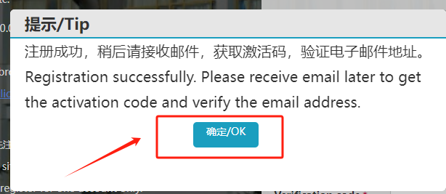

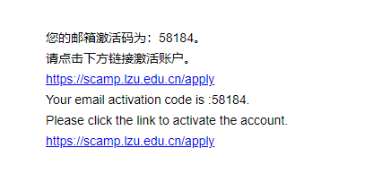
Click on "active account" to activate your registered email account.
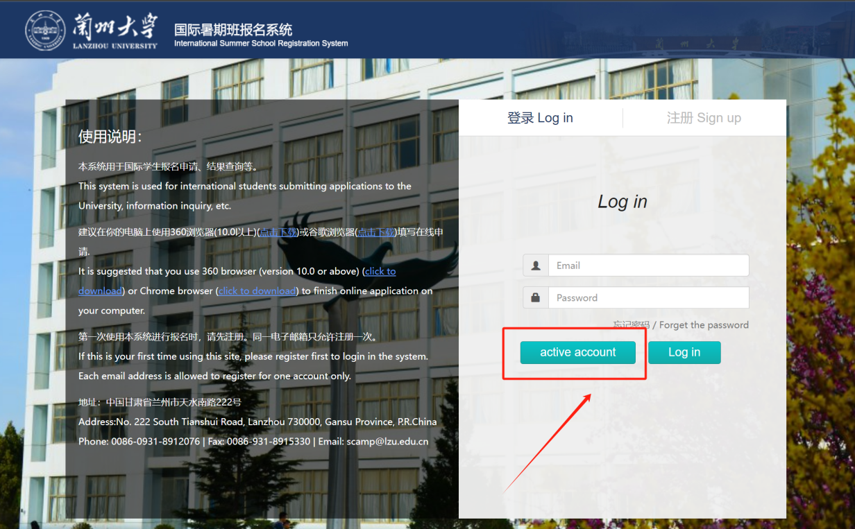
On the account activation page, enter your registered email account in the "Email" field, the activation code received in your email in the "Code" field, then input the correct verification code. Finally, click the "active" button to activate your account.
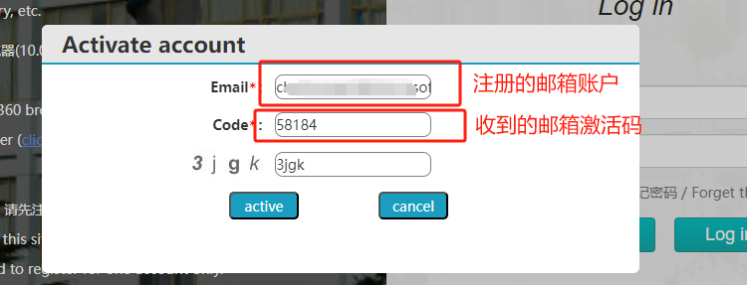

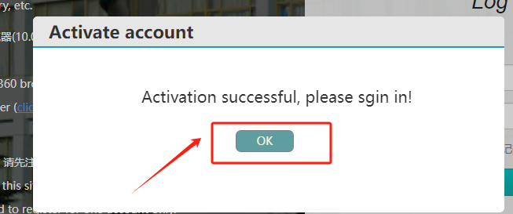

After successful activation, you can use the account credentials you registered with to log in.

2.2 Login

Open your browser and enter the following address in the address bar: https://scamp.lzu.edu.cn/apply to access the system's login/registration page. Then, click on "登录 Log in".
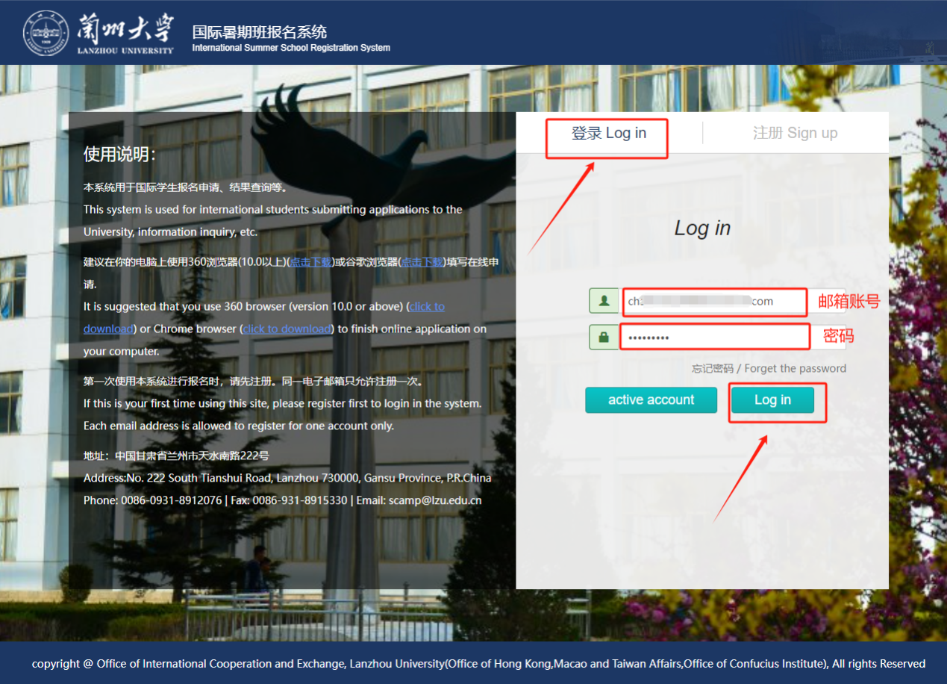

2.3 Forgot Password

If you forget your login password, you can click on the "忘记密码 / Forget the password" button on the login page to retrieve your password.
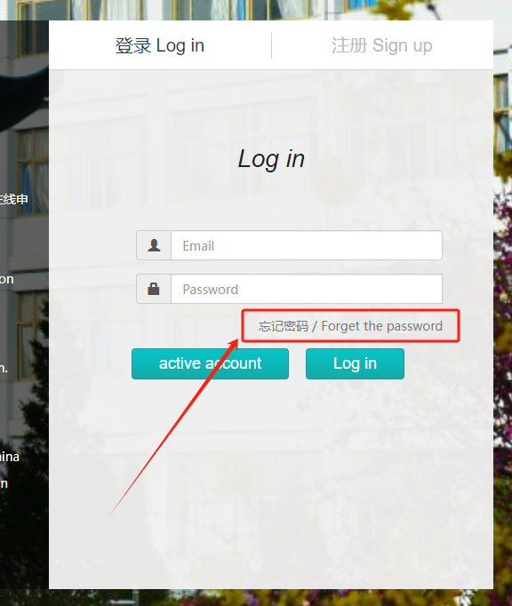
After accurately filling out the information, click on the "submit" button at the bottom left. Upon successful submission, the reset password will be sent to the registered email address.
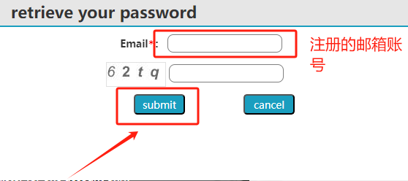

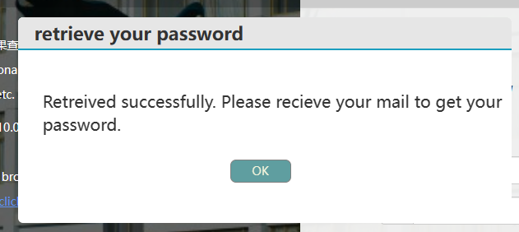

After successful login, applicants can change their passwords by clicking on "Change Password."
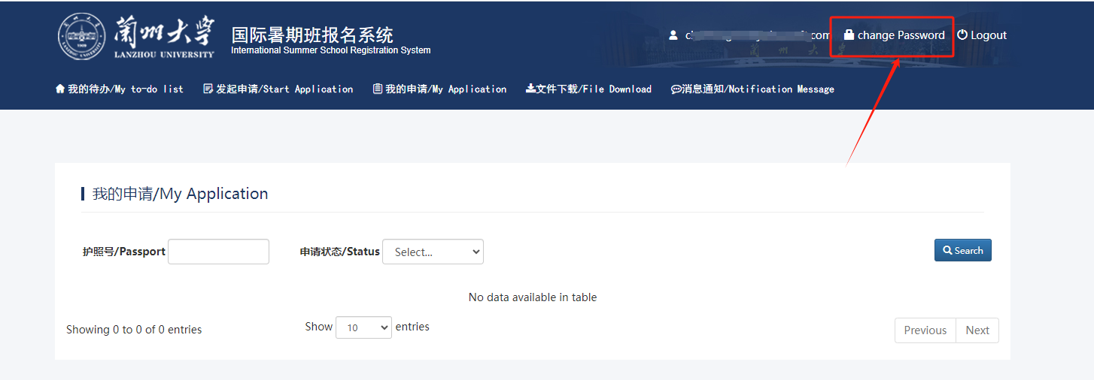
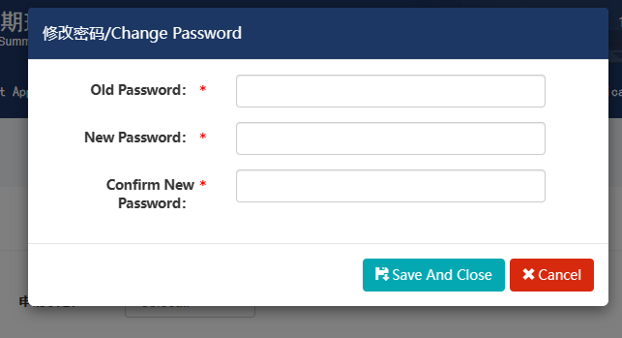
After completing the password change information, click on the "Save And Close" button to save your changes.
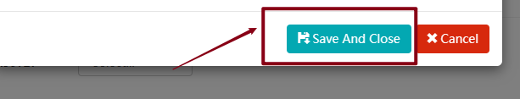
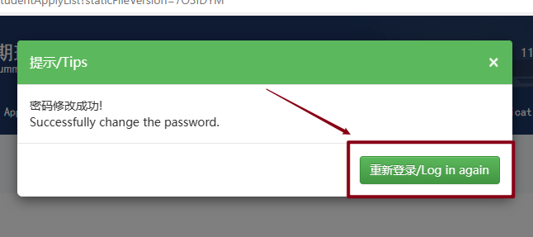
After successfully saving the new password, clicking "重新登录/Log in again" will return you to the login page. You can now log in successfully using the new password.

Chapter 3: System Application

3.1 View Important Notices for Online Application

Click on "Important Notice for Online Application/在线申请重要通知" to view.
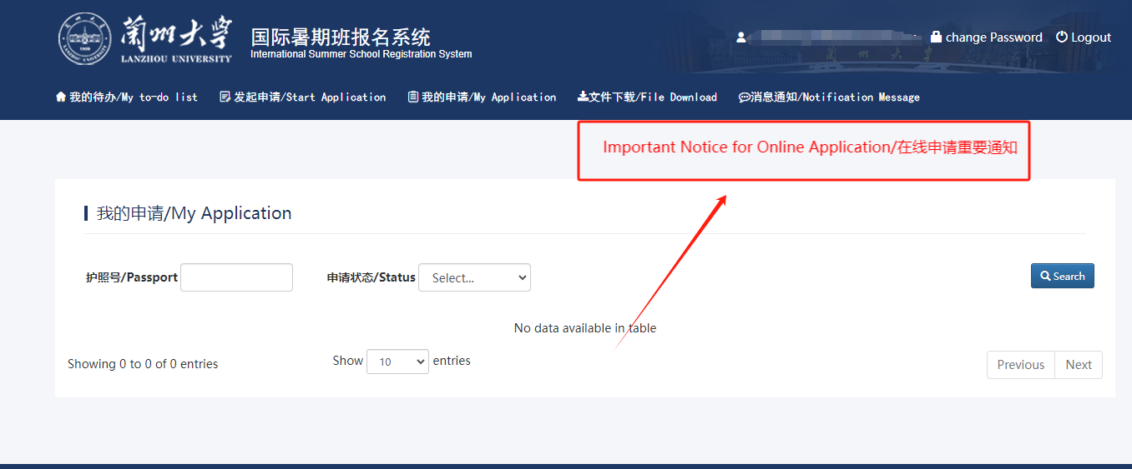
3.2 View My Applications

After successfully logging into the system, you will be directed to the "我的申请/My Application" page by default. Here, you can view your applications and quickly search based on "Passport Number" or "Application Status."

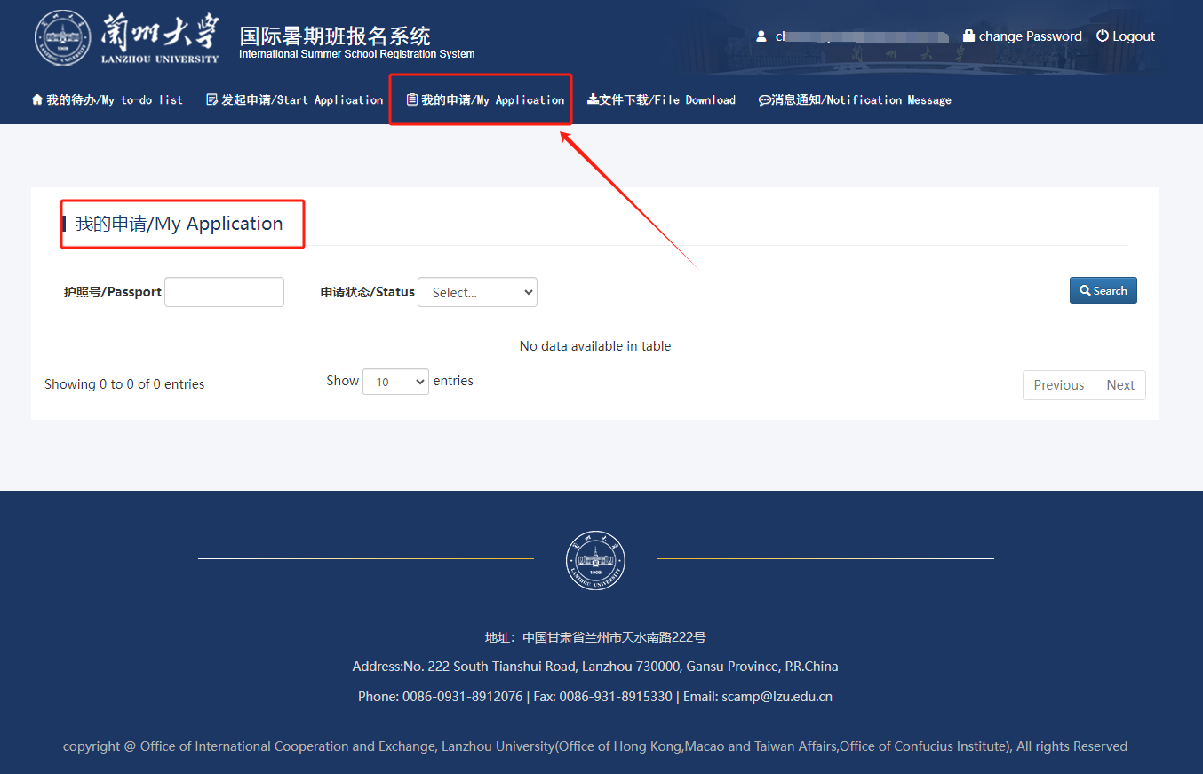
Click on the name to view the details of this application.

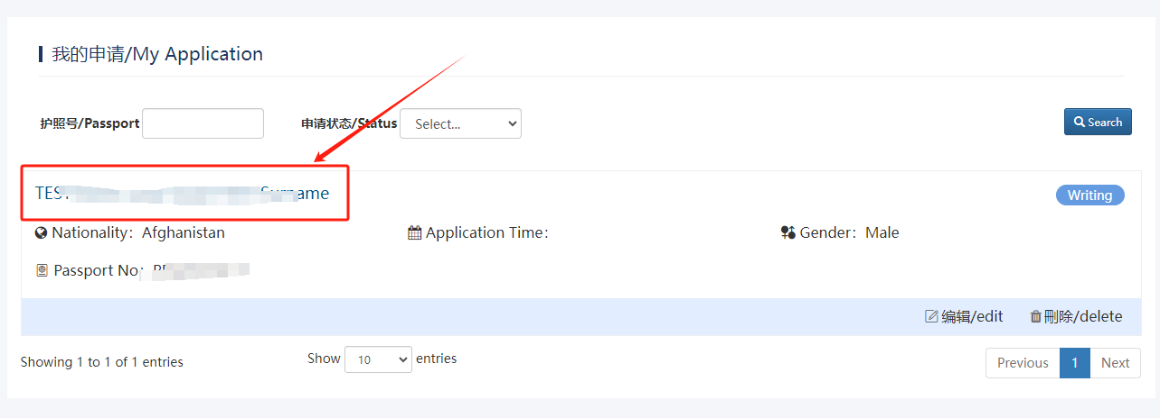
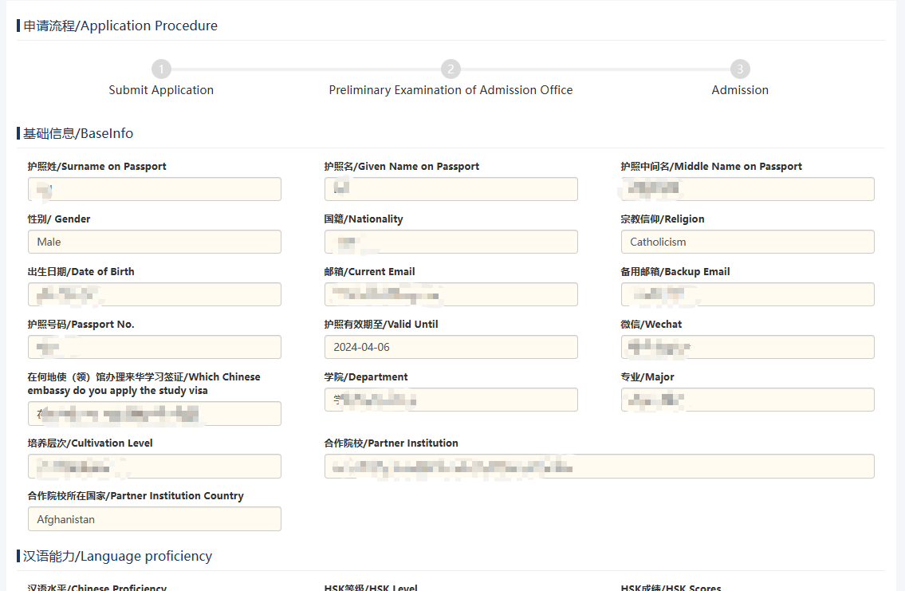
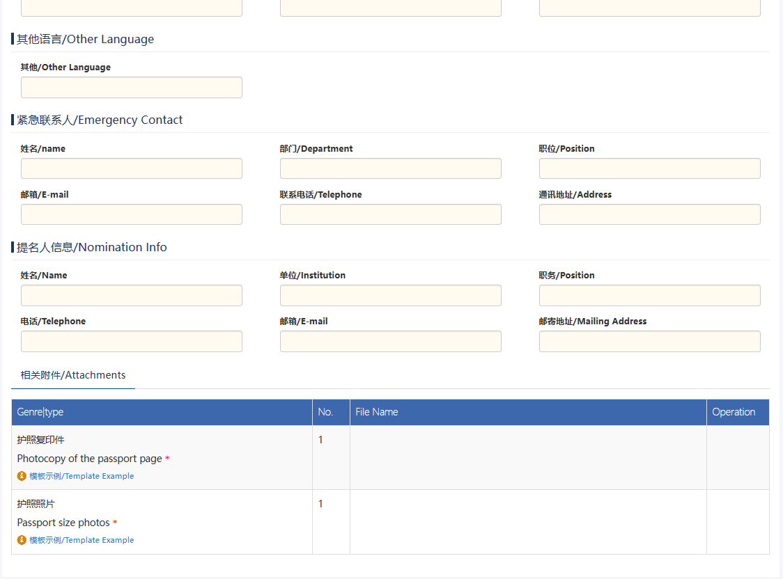

3.3 Initiating an Application

Click on the top menu "发起申请/Start Application". After carefully reading the applicant's guarantee, click on the "已阅读并开始办理/Read complete and start processing" button to enter the editing page.

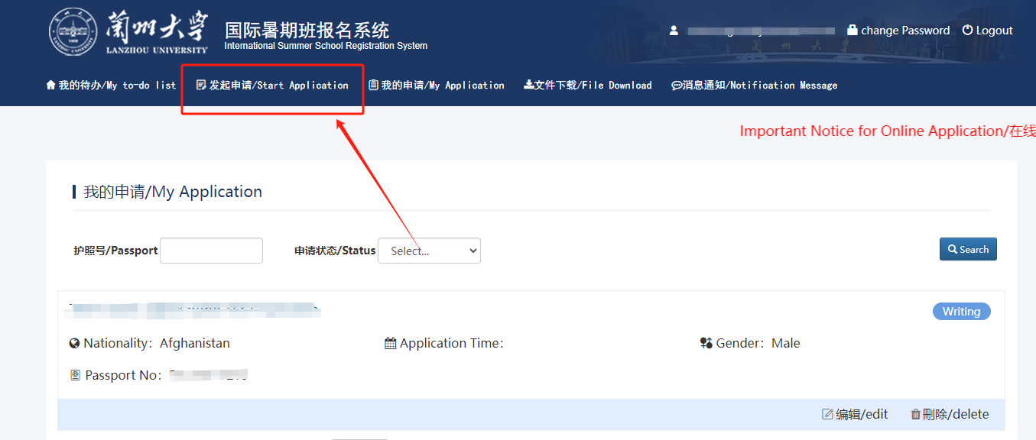

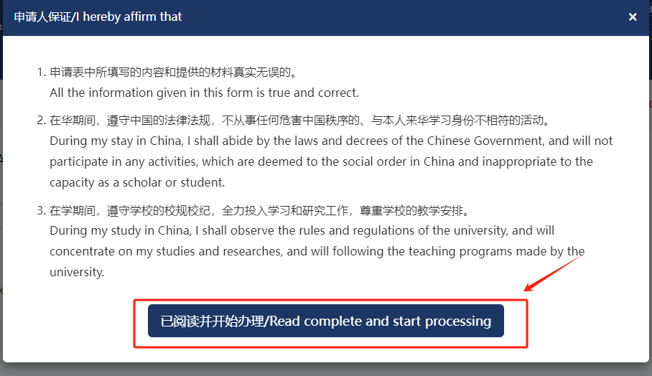

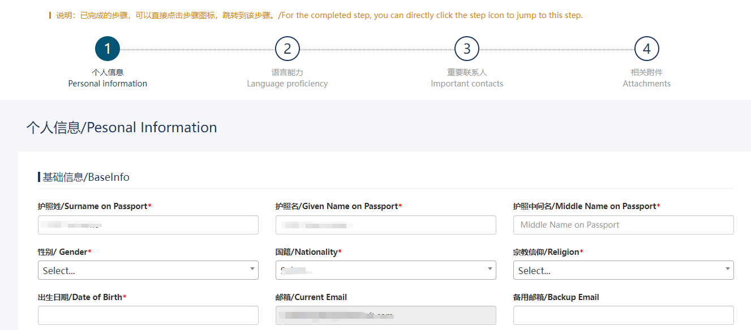
1. Click on "保存并下一步/Save And Next" to save the current progress and proceed to the next step.

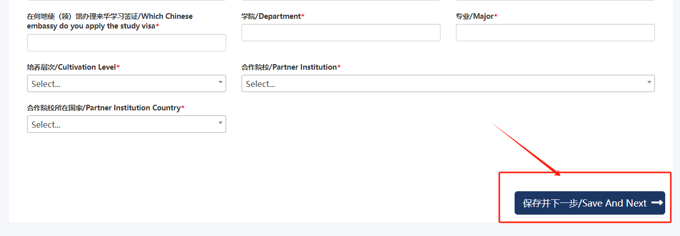
2. Click on "上一步/ Previous" to go back to the previous filling page.

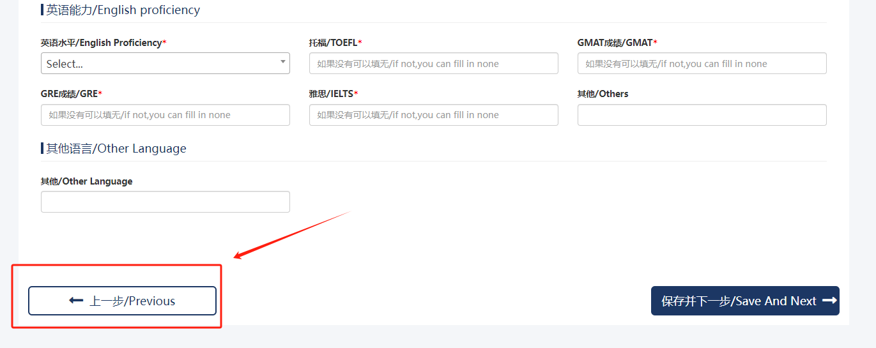

3. After completing the application information, click on "提交申请/Submit Application" on the last step.
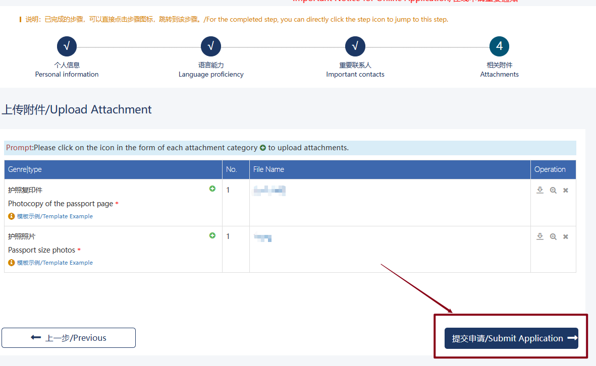
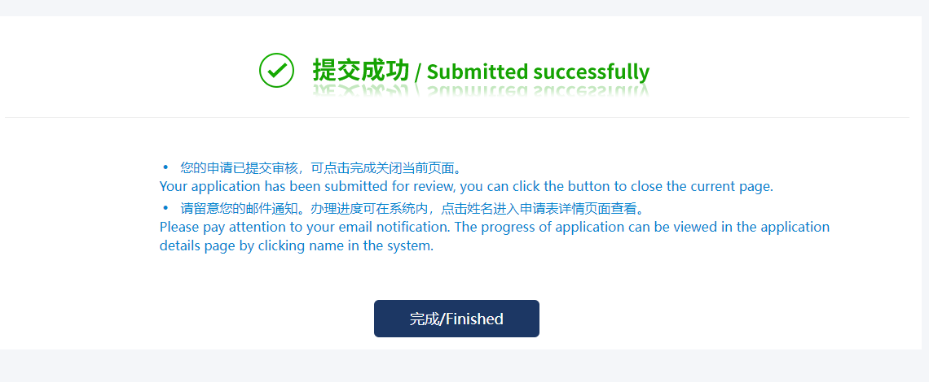
Once submitted, the application can be viewed in "My Application".
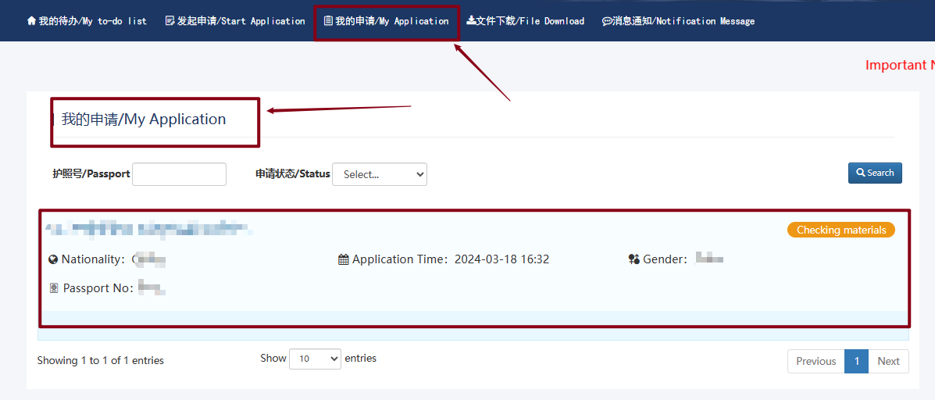

Clicking on the applicant's name in the application list will take you to the application details page where you can view the current application processing status.

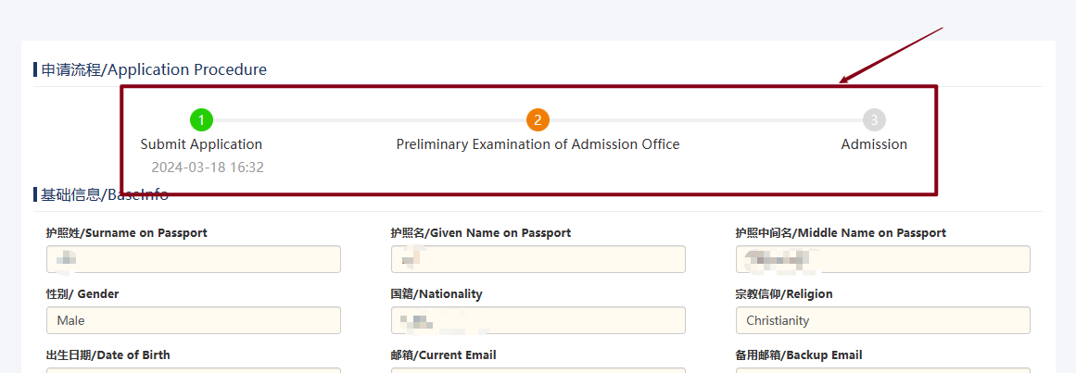

3.4 File Downloads

Click on the "文件下载/File Download" menu at the top to enter the file download page. Only after the application is approved can you download the "Admission Letter" and "Invitation Letter for Short-term Visit to China." Otherwise, downloading is not permitted.

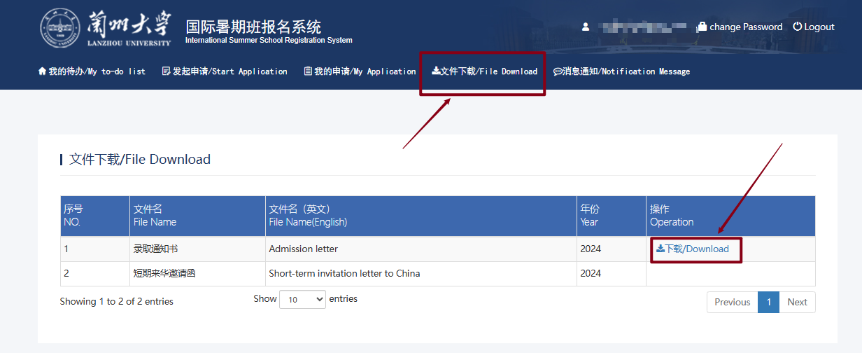

3.5 Notification Messages

Click on the "消息通知/Notification Message" menu at the top to enter the notification message page. Here, you can view received audit messages and reminder notifications.

